 CHEMICAL ENGINEERING TRANSACTIONS  VOL. xxx, 2026 | A publication of  
The Italian Association
of Chemical Engineering
Online at www.cetjournal.it

Guest Editors: Leonardo Tognotti, Rubens Maciel Filho, Viatcheslav Kafarov
Copyright © 2026, AIDIC Servizi S.r.l.
ISBN 979-12-81206-xx-x; ISSN 2283-9216

Superstructure Optimization for Gamma-Valerolactone Production from Lignocellulosic Biomass
Bárbara L. S. Santiago*, Reginaldo Guirardello
ªSchool of Chemical Engineering, University of Campinas, Av. Albert Einstein 500, 13083-852, Campinas-SP, Brazil.
blsilvasa@gmail.com

Growing interest in renewable feedstocks has driven the development of new strategies to identify the most efficient processes for converting biomass into valuable chemicals. In this context, this work presents a superstructure optimization for producing gamma‑valerolactone (GVL) from sugarcane bagasse, integrating pretreatment, levulinic acid synthesis, hydrogenation, separation, and electricity cogeneration from lignin. Multiple pretreatment and downstream alternatives were evaluated, including furfural valorization and two hydrogenation routes (molecular hydrogen and isopropanol as a hydrogen donor).
A MILP formulation was applied to identify the economically optimal configuration under mass, energy, and cost constraints. The optimal design selects steam‑explosion pretreatment, reactive distillation for furfural, solvent extraction for levulinic acid recovery, and H₂‑based hydrogenation to GVL.
Economic assessment yields a positive NPV (50 million USD) at a GVL price of 2.5 USD/kg and a furfural price of 2 USD/kg. Sensitivity and scenario analyses highlight the importance of catalyst performance and full valorization of hemicellulose to improve overall process feasibility.
  - Introduction
The transition toward sustainable energy and chemicals requires the development of integrated biorefineries capable of converting lignocellulosic biomass into high‑value products, as highlighted in several techno‑economic studies on biomass pretreatment and conversion pathways (Baral & Shah, 2017). Biomass stands out as an excellent renewable feedstock due to its abundance, low cost, and potential to replace fossil‑derived resources in large‑scale industrial processes. Within this context, superstructure optimization emerges as a powerful approach, enabling the systematic evaluation of multiple process alternatives under both economic and technical constraints, following the principles of process systems engineering described by Biegler, Grossmann, and Westerberg (1997). By simultaneously considering a wide range of process configurations, superstructure‑based methods can identify the most promising production pathways, thereby reducing uncertainty and supporting informed investment decisions.
Among the portfolio of bio‑based chemicals, gamma‑valerolactone (GVL) has gained significant attention due to its versatility as a green solvent, fuel additive, and platform molecule for the synthesis of polymers and fine chemicals. A key step in its production is the formation of levulinic acid, an essential intermediate obtained from the acid‑catalyzed conversion of lignocellulosic carbohydrates. Producing GVL from renewable feedstocks aligns with global efforts to replace fossil‑derived chemicals with sustainable alternatives, as reinforced by recent techno‑economic assessments of GVL production routes (Byun & Han, 2019; López‑Aguado et al., 2022).
This work focuses on the optimization of a superstructure for GVL production from sugarcane bagasse, an abundant agricultural residue in Brazil. The proposed model integrates pretreatment, levulinic acid formation, hydrogenation to GVL, separation, and cogeneration of electricity from lignin, with the objective of determining the most economically viable process configuration. The optimization targets the maximization of net present value (NPV), while explicitly accounting for capital expenditures, operating costs, and process yields. Insights from integrated biorefinery analyses, such as those by Wiranarongkorn et al. (2023), further support the importance of evaluating multiple valorization pathways for hemicellulose‑derived products.
  - Methodology
The methodology developed in this work integrates superstructure optimization with detailed process modeling to evaluate alternative pathways for producing gamma-valerolactone (GVL) from lignocellulosic biomass. The approach begins with the construction of a comprehensive superstructure (Figure 1) that includes pretreatment options, furfural formation from hemicellulose, levulinic acid (LA) production as the key intermediate, hydrogenation of LA to GVL, product-separation steps, and energy cogeneration from lignin (Table 1). Technical parameters such as reaction yields, separation efficiencies, and energy requirements are incorporated alongside economic factors including capital investment and operating costs. By embedding these elements into a unified optimization framework, the methodology enables the systematic identification of the most economically favorable biorefinery configuration, assessed through the maximization of net present value (Santiago, 2025). The optimization problem was implemented in the General Algebraic Modeling System (GAMS), a high-level algebraic modeling environment widely used for formulating and solving large-scale mixed‑integer linear programming (MILP) problems.
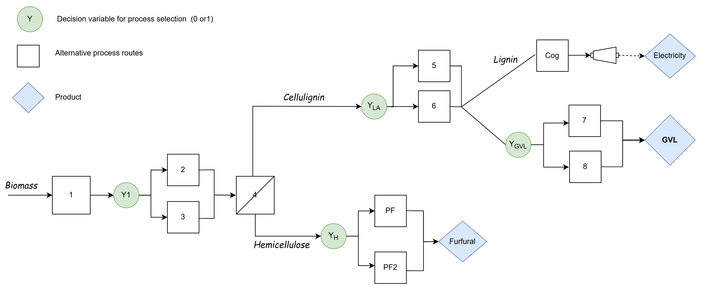
Figure 1: Superstructure representing all alternative units in the process
Table 1: Process alternatives
Process | Description
P1 | Reception and milling of biomass
P2 | Steam-explosion pretreatment
P3 | Acid pretreatment
P4 | Separation of cellulignin and hemicellulosic hydrolysate
PCog | Lignin combustion and cogeneration of electricity
PF | Furfural production via reactive distillation
PF2 | Furfural purification through solvent extraction and simple distillation
P5 | LA production – LA extraction and H₂SO₄ recycling
P6 | LA production – H₂SO₄ neutralization
P7 | GVL production – H₂ as hydrogen source
P8 | GVL production – isopropanol (IPA) as hydrogen source

    - Pretreatment options
The purpose of the pretreatment step is to hydrolyze hemicellulose into soluble sugars—mainly xylose, but also mannose, arabinose, and glucose. This step also releases acetyl groups as acetic acid, which promotes hydrolysis reactions and reduces cellulose recalcitrance by partially solubilizing lignin. Pretreatment additionally enables biomass fractionation into solid and liquid streams, since hydrolyzed hemicellulose is water-soluble while unreacted cellulose and lignin remain in the solid phase. The model includes two types of pretreatments: acid and steam Explosion described by Baral and Shah (2017). Both treatments employ a solid-to-liquid ratio in the feed corresponding to 30% w/w biomass, with the remaining fraction consisting of water and chemical reagents. Sulfuric acid is introduced at a concentration of 1% w/w.
    - Hemicellulose destination
In this work, hemicellulose was not directed toward the production of the main product (GVL) because it requires very specific reaction pathways. However, since it accounts for about 30% of the biomass mass, its economic impact cannot be overlooked. To ensure proper utilization, two scenarios for furfural production were considered, with costs based on Wiranarongkorn et al. (2023) and Contreras-Zarazúa et al. (2022).
Furfural can be produced through xylose dehydration and is used in several industries, including pharmaceuticals, biofuels, plastics, resins, and oils. A major challenge is minimizing humin formation, which lowers yield and increases production costs. Wiranarongkorn et al. describe a reactive distillation process using acetic acid as a catalyst, followed by azeotropic separation and purification. Contreras-Zarazúa et al. propose liquid–liquid extraction with butyl chloride to avoid the water–furfural azeotrope, enabling purification through a single distillation step.
    - Electricity cogeneration
The unconverted organic fraction (mainly lignin and humins) can be burned to produce steam and electricity, making the plant energy self-sufficient and potentially generating surplus electricity as a revenue source. This also reduces solid waste disposal costs, improving the overall economic feasibility.
Cogeneration was modeled following Humbird et al. (2011), using a boiler and a multistage turbogenerator. The boiler burns wet organic residues to produce high-pressure superheated steam, while the turbogenerator generates electricity and intermediate-pressure steam for process use, finally condensing residual steam under vacuum for maximum energy recovery.
Key parameters considered: steam capacity of 239 ton/h at 454°C and 900 psig; boiler efficiency of 80%, turbine efficiency of 75%, and generator efficiency of 97%. The higher heating values of lignin and humins were estimated at ~25,000 kJ/kg. The system is closed and energy self-sufficient, with a specific water/steam consumption of 7 kg per kg of dry feed. Operational costs excluded chemical conditioning and particulate removal.
    - Levulinic acid (LA) as an intermediate of the process
The production of LA is required because it is an intermediate in the GVL synthesis pathway. Two alternative processes were evaluated for converting cellulose into levulinic acid (LA), differing primarily in their catalyst‑reuse strategies. In all cases, cellulose is hydrolyzed to glucose, dehydrated to HMF, and rehydrated to LA and FA in the same homogeneous reactor catalyzed by H₂SO₄ (3 wt%).
One process alternative was described by Zhang et al. (2024). It involves neutralizing sulfuric acid with Ca(OH)₂, followed by two distillation columns. The first separates FA at the top, while the second provides LA at 99 wt% also at the top, sending the water-rich bottom stream to the wastewater treatment station.
Another alternative was described by Zhang et al. (2024) and includes an additional liquid–liquid extraction step for LA using 2-Me-THF. The main advantage of this alternative is the reduction in energy consumption and catalysts costs, since both are fully recovered, representing a low operational cost for make-up. The extraction concentrates LA in the organic phase, separating it from water and allowing its separation from FA in the second distillation column with 99 wt% purity. The aqueous phase leaving the extractor is reused to recover the diluted acid, reducing catalysts costs.

    - Gamma-Valerolactone (GLV) production
GVL production from LA can follow two alternative hydrogenation routes, distinguished by the hydrogen source: molecular H₂ or an alcohol acting as a hydrogen donor (Figure 2). The H₂-based route is more established but requires high-pressure, high-temperature operation, while the alcohol-based route aims for improved safety and sustainability.
In the H₂ Route (P8), Byun and Han (2019) describe LA hydrogenation using a RuSn/C catalyst in propyl guaiacol solution, achieving a 99% molar yield. The reactor effluent is processed in two distillation columns: the first recovers and recycles the solvent and unreacted LA, and the second purifies GVL to 99 wt%.
In the alcohol-donor Route (P9), isopropanol (IPA) supplies hydrogen, avoiding the use of gaseous H₂. The reaction occurs in a stirred CSTR with a Zr-Al-Beta bifunctional catalyst, reaching an 86 wt% yield. The large excess of IPA requires recycling and may lead to DIPE formation. Product purification involves four distillation columns to recover GVL, separate DIPE, recover IPA via extractive distillation with glycerol, and finally regenerate the glycerol for reuse (López-Aguado et al., 2022).

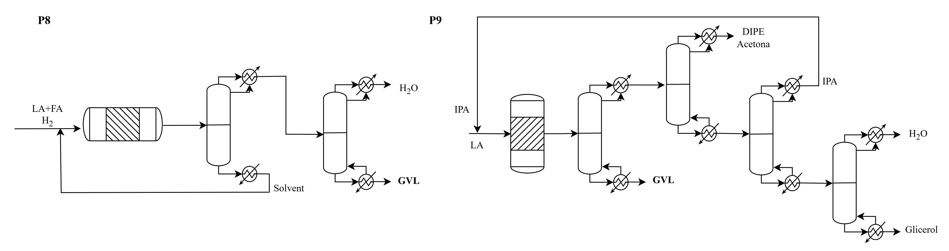
Figure 2: Alternative process routes to produce gamma‑valerolactone from biomass using levulinic acid as an intermediate: P8, which uses H₂ as the hydrogen donor, and P9, which uses isopropanol (IPA) as the hydrogen donor.
    - Economic assumption and optimization strategies
The plant operates with an hourly feed rate of 15 t/h and applies an 8% discount rate. Construction is assumed to take one year, followed by a 25-year plant lifetime with 200 productive days per year (4,800 operating hours). Production reaches 100% of nominal capacity in the first year, and the project is financed entirely with equity, with no debt. A corporate income tax rate of 34% is applied. Depreciation follows a linear method over 10 years, and no salvage value is considered. The fixed capital investment (FCI) is estimated as 1.88 times the purchased and installed equipment cost, while working capital corresponds to 5% of FCI. Fixed annual operating costs, including labor and maintenance, are assumed to be 2% of FCI.

The proposed optimization problem, as described by Santiago (2025), consists of the following elements:
- Mass and energy balance equations
- Equations describing the process units (for example, conversion of raw materials into products in the reactors)
- Constraints inherent to the evaluated processes (for example, a maximum of ten stages for extraction)
- Capital cost of each unit (for example, the relationship between the number of extraction stages and the capital cost of the column)
- Operating cost of the process
- Economic objective function
Considering that there are alternative operations for the same process step, and that these steps are often nonlinear, the resulting mathematical model would be a Mixed Integer Nonlinear Problem (MINLP)
Finding the solution to a Mixed Integer Nonlinear Problem can be particularly challenging; therefore, a variable discretization methodology was applied to linearize the problem, transforming it into a Mixed Integer Linear Problem (MILP), as suggested by Biegler, Grossmann, and Westerberg (1997).

  - Results
In the optimized GVL production process, it was possible to identify the sequence of alternative process routes. The model incorporates capital costs, operating costs, and raw‑material and product prices to assess economic performance, maximizing the plant’s net present value. The resulting process consists of the stages of steam‑explosion pretreatment, solid–liquid separation of the hemicellulosic hydrolysate, conversion of cellulignin into LA and then into GVL, furfural production, and electricity cogeneration (Table 2).
The optimization resulted in selecting P7, which converts LA to GVL in the presence of gaseous H₂ with a heterogeneous catalyst (RuSn) and propyl guaiacol (PG) as solvent in a fluidized‑bed reactor, achieving a molar yield of 93%. The solvent is recycled in the system after a distillation column, with a small loss (0.01 wt%). The second column separates water from purified GVL for sale. The highest operating cost is H₂, followed by the energy required for purification and catalyst regeneration. Regarding capital cost, the largest contributor is the reactor, due to the large volume required by the long residence time of the reaction.

Table 2: Optimization result
Decision | Optimization outcome | Interpretation
Y1 | P2 = 1; P3 = 0 | Steam-explosion pretreatment (P2) is prioritized over diluted-acid pretreatment (P3)
YH | PF = 1; PF2 = 0 | PF (reactive distillation) is prioritized for furfural production
YLA | P5 = 1; P6 = 0 | P5 (solvent extraction with catalyst reuse) is prioritized for the production of the intermediate, levulinic acid (LA).
YGVL | P7=1; P8=0 | P7 (H2 hydrogen donor) is prioritized for GVL production

The alternative process P8 was not prioritized primarily because of its high operating cost. P8 uses IPA (isopropyl alcohol) as a hydrogen donor instead of H₂ (P7). The advantage of this process is avoiding high‑pressure operations that require specific installations and involve operational risks. However, the costs associated with this sacrificial alcohol were prohibitive, especially due to side reactions that not only increased the complexity of GVL purification but also raised the operating cost for IPA makeup. Regarding purification, the reactor effluent contained GVL, IPA, DIPE (di‑isopropyl ether), acetone, and water. GVL is recovered in the first column, but two additional columns are required for purification and IPA recycling. The second column separates DIPE and acetone at the top, while the last column must be extractive with glycerol due to the azeotropic mixture of IPA and water. The loss of IPA in the process and the need for make‑up make it account for almost the entire raw‑material cost, not only because its unit cost is higher than LA, but also because it must be used in large excess to achieve attractive yields (85 wt%). This also contributes to the plant’s capital cost, since the reactor alone represents 28% of this cost due to its large volume resulting from the long reaction time.
Di‑isopropyl ether (DIPE) is formed in the undesired condensation reaction by auto‑esterification of IPA in the presence of Brønsted acid catalysts, such as the Al‑Zr‑Beta catalyst required for converting LA to GVL. Supporting this observation, López‑Aguado et al. (2022) presented a sensitivity analysis on the impact of DIPE yield on the economic feasibility of producing GVL with IPA. According to the authors, a 36% reduction in the molar yield of this undesired reaction reduces the minimum selling price of GVL by 31% (2111 €/t). Therefore, the feasibility of using a sacrificial alcohol instead of H₂ in GVL production strongly depends on the development of catalysts that reduce undesired DIPE formation.
The low economic attractiveness of GVL production can be worsened by directing the hemicellulosic fraction to low‑value products, as discussed by Byun and Han (2019). The selling price of hemicellulose‑derived byproducts can vary widely (USD 0.76–1.6/kg), which economically affects the process by altering the minimum selling price of GVL. The authors evaluated the impact of four alternative products obtained from hemicellulose on the feasibility of producing GVL from cellulose: xylose, furfural, furfuryl alcohol (FFA), and maleic anhydride (MA). The selling prices considered in the analysis were 0.36, 0.76, 1.0, and 1.6 USD/kg, respectively, while the molar yields considered were 1.0, 0.78, 0.75, and 0.57, respectively. Evaluating each alternative, the minimum selling price of GVL varied significantly: 2.36, 1.34, 1.34, and 0.36 USD/kg, respectively. In other words, even with a low molar yield (57%), MA enabled a large reduction in the GVL selling price (USD 0.36/kg), improving its economic feasibility and highlighting the importance of valorizing all sugar fractions of the biomass.

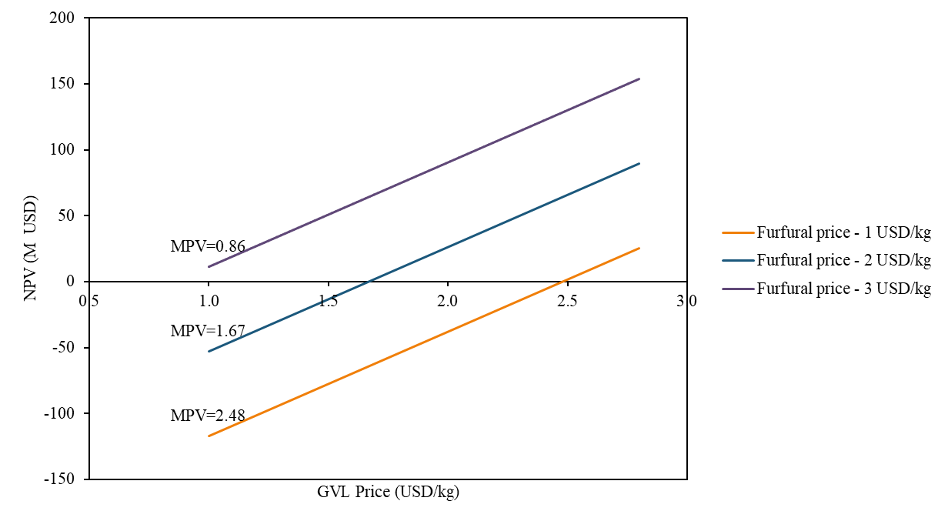
Figure 3: Sensitivity analysis of the selling price of GVL and furfural

A sensitivity analysis of the selling prices of GVL and furfural was conducted to support process evaluation. Figure 2 shows how variations in these prices influence the economic profitability of the process (NPV); as expected, the NPV increases with higher product prices. When the furfural price is 2 USD/kg, the minimum selling price (MSP) of GVL is 1.71 USD/kg. If the furfural price rises to 3 USD/kg, the GVL MSP decreases to 0.86 USD/kg.

  - Conclusions
In the optimized GVL production process, a sequence of alternative routes was identified and evaluated using a model that integrates capital and operating costs, as well as raw-material and product prices, to maximize the plant’s net present value. The resulting configuration includes steam-explosion pretreatment, solid–liquid separation of the hemicellulosic hydrolysate, conversion of cellulignin into levulinic acid (LA) and subsequently into GVL, furfural production, and electricity cogeneration. The process is economically viable, achieving a net present value of 50 million USD, assuming a GVL selling price of 2.5 USD/kg. The minimum selling price (MSP) of GVL — corresponding to NPV = 0 — is 1.71 USD/kg when furfural is sold at 2 USD/kg. If the furfural price increases to 3 USD/kg, the GVL MSP decreases to 0.86 USD/kg

Acknowledgments
The authors acknowledge the financial support from Coordenação de Aperfeiçoamento de Pessoal de Nível
Superior (CAPES - grant n. 88882.329720/2019-01) and São Paulo Research Foundation (FAPESP – grant n.
2022/16379-8).

References
Baral, N.R., Shah, A., 2017. Comparative techno-economic analysis of steam explosion, dilute sulfuric acid, ammonia fiber explosion and biological pretreatments of corn stover. Bioresource Technology, 232, 331–343.
Biegler, L.T., Grossmann, I.E., Westerberg, A.W., 1997. Systematic methods for chemical process design. Prentice Hall, Old Tappan, NJ (United States).
Byun, J., Han, J., 2019. Catalytic conversion of corn stover for gamma-valerolactone production by two different solvent strategies: Techno-economic assessment. Energy, 175, 546–553.
Contreras-Zarazúa, G., Martin-Martin, M., Sánchez-Ramirez, E., Segovia-Hernández, J.G., 2022. Furfural production from agricultural residues using different intensified separation and pretreatment alternatives: Economic and environmental assessment. Chemical Engineering and Processing – Process Intensification, 171.
Humbird, D., Davis, R., Tao, L., Kinchin, C., Hsu, D., Aden, A., Schoen, P., Lukas, J., Olthof, B., Worley, M., Sexton, D., Dudgeon, D., 2011. Process design and economics for biochemical conversion of lignocellulosic biomass to ethanol: Dilute-acid pretreatment and enzymatic hydrolysis of corn stover. NREL Technical Report NREL/TP‑5100‑51400, Golden, CO (United States).
López-Aguado, C., Del Monte, D.M., Paniagua, M., Morales, G., Melero, J.A., 2022. Techno-economic assessment of conceptual design for gamma-valerolactone production over a bifunctional Zr-Al-Beta catalyst. Industrial & Engineering Chemistry Research, 61(16), 5547–5556.
Santiago, B.L.S., 2025, Superestructure optimization (MILP) for the design of a multiproduct biorefinery, PhD Thesis, Unicamp, Campinas, Brazil. https://repositorio.unicamp.br/acervo/detalhe/1540213
Wiranarongkorn, K., Im-Orb, K., Patcharavorachot, Y., Maréchal, F., Arpornwichanop, A., 2023. Comparative techno-economic and energy analyses of integrated biorefinery processes of furfural and 5-hydroxymethylfurfural from biomass residue. Renewable and Sustainable Energy Reviews, 175, 113146.
Zhang, H., Hou, L., Zhang, W., Lin, Y., Liu, X., Zhao, S., Chang, C., 2024. Coupling process for preparing biomass-based furfural and levulinic acid from corncob: Extraction, green chemistry and techno-economic assessment. Bioresource Technology, 394, 130301.

